All staff at Flinders have access to Cisco cloud WebEx at https://flinders.webex.com click 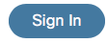in the top right of the page and login with your full email address.
To schedule a webinar click on the Schedule webinar button.
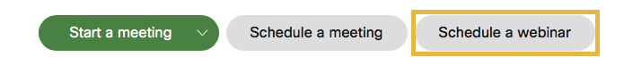
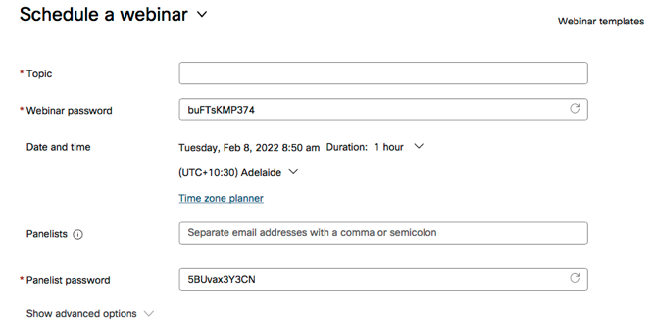

There are just a few fields you need to fill in and you can get underway.

Topic- this is the name of your event
Date and time- set the date and time of your event
Panelists- enter names of Flinders staff or email addresses of external people

If inviting a Flinders staff member as a panelist you can also make them a cohost
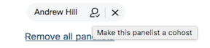
Click on the head icon next to the person’s name and choose Make this panelist a cohost. This can be very helpful if the person who schedule the webinar is not attending the webinar, a cohost can start and end a webinar.

Click on the date link to set the date and time of the event
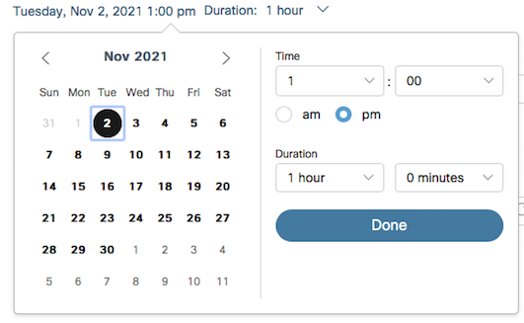
Choose from the calendar the date of your webinar and set the time you want the attendees to join the event. Any scheduled event can be started by the host or a cohost anytime prior to the scheduled start time. Duration is an indicator to your attendees of how long the session will go, however the event will not stop at the set duration it will only end when the host ends the webinar.

At the bottom of the webinar scheduling page is the advanced options
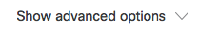
If you click the V down arrow this will display all the advanced options
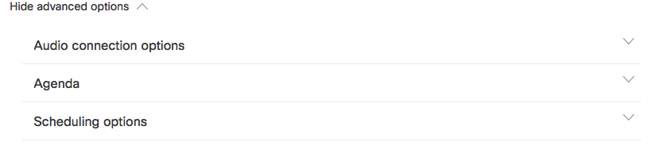
If you expand the Audio connection options you can see what can be set when scheduling a webinar
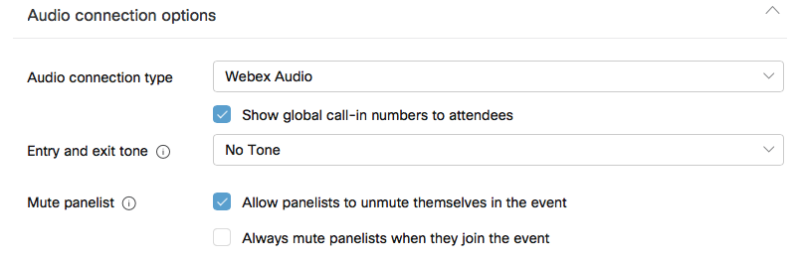
Mute panelist can be helpful as there are some setting that can make your webinar easier to manage check or uncheck options. If you would like to get attendees to register for access to your event check Registration Required check box.
Once you have setup all you options you need to click the 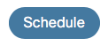button this will send out an email to the host and all the panelists with a join link to click on. The host is also sent out an attendee invitation which can be sent out to an email list or the link can be published on a website.

